**NCBA M-Pawa Recycling Automation Process TRS**

**Prepared by: Kenedy Manga Ogola**

**Reviewed by: Stanley Muthama**

NCBA M-pawa Recycling Automation TRS

Prepared by: Kenedy Manga

Reviewed by: Stanley Muthama

1. **Objective**

M-pawa Recycling automation process is offering solution to enable the end-to-end process of automation of the recycling process and archiving the MSISDN in real time.

1. Step 1: **RECYCLING PROCESS VODACOM**
   1. User logs in and provides the MSSIDN to be recycled or a trigger originates from ICAP to recycle customer in MPESA due to 270 days of inactivity then pushes to G2.
   2. At G2 the number is recycled
   3. In addition, the same time issue a trigger to IPG to notify that a customer has been triggered at G2 side.
   4. At the IPG the vmtref is pulled.
   5. Notification is sent out to NCBA for a phone number that is recycled.
   6. NCBA to acknowledge the receipt of the request.
   7. NCBA to process the request.
   8. NCBA to share a callback request to Vodacom once the recycling process is completed on NCBA side.
   9. If the request has timed out notify NCBA of a timeout.
   10. After the end of day send to NCBA the result of recycled and the response to NCBA.

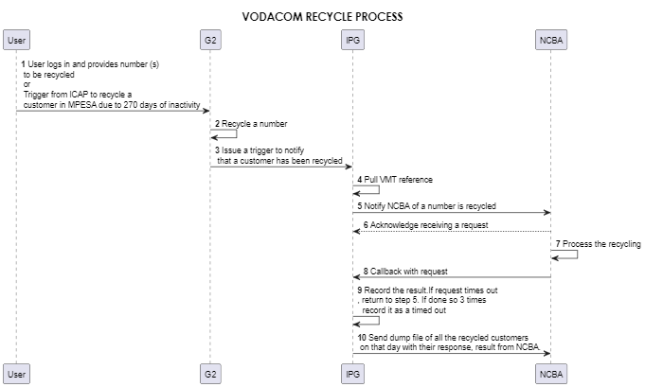

1. Step2: **RECYCLING PROCESS NCBA**
   1. Vodacom pushes recycling request via API (MSSIDN and VMT ref) to NEO.
   2. Return an acknowledgement of successful receipt of recycling request to Vodacom.
   3. The request is pushed to the Gateway(OGW)
   4. Neo via the Gateway pushes the request to Nginx.
   5. Nginx then pushes the request to the Industry Application Service (IAS).
   6. IAS pushes the request to URM
   7. At the URM, it checks the parameters (vmtref and the MSSIDN), if the customer exists and the status is normal.
   8. If the customer is not normal in NEO return to Vodacom, recycling process unsuccessful
   9. If the customer is normal, perform the following operations: change the status of the customer to **Recycle** status **4,** place the current MSISDN to **old phone number,** place the user to **Post-no-debit restriction** and append **the ! to user number.**
   10. Then push the request back to Vodacom for notifying for successful recycling.
   11. Queue the user to be shared on an excel file of a successful recycled customers to Vodacom.

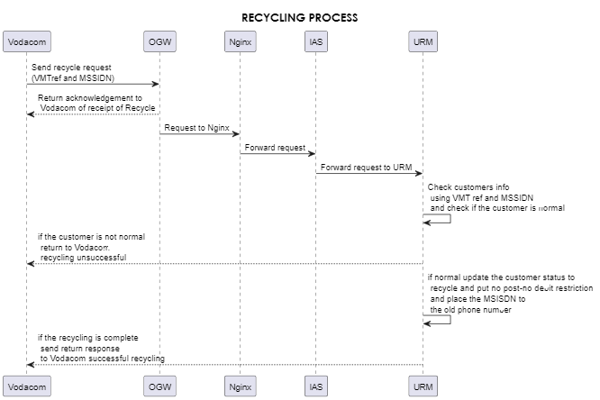

Step 3: **REINSTATING RECYCLING PROCESS**

1. The request is pushed to the Gateway(OGW)
2. Neo via the Gateway pushes the request to Nginx.
3. Nginx then pushes the request to the Industry Application Service (IAS).
4. IAS forwards the request to URM.
5. At the URM check if the customer exist and is recycled.
6. If the customer is not recycled, return to Vodacom unsuccessful reinstating.
7. If the customer is recycled, perform the following operations; release the **Post no-debit restriction**, change the old phone number to **MSSIDN** and change the customer status from recycled to **normal**.
8. Return the response back to Vodacom of a successful reinstating.

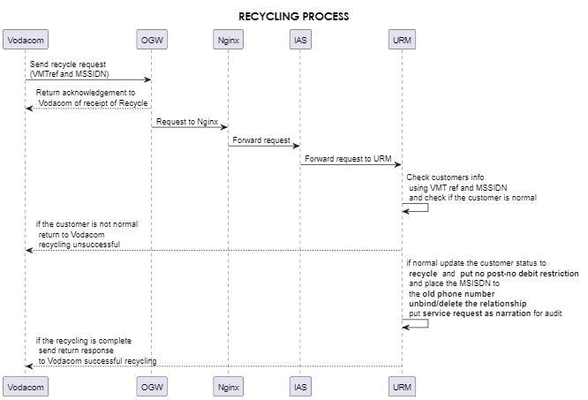

1. **API Capability**

Recycle Request API.

**Request Sample.**

<REQUEST>

<SERVICE>CUSTOMER_RECYLE _NOTIF</SERVICE>

<CONVERSATIONID>dnoi83724242sds<CONVERSATIONID>

<USERNAME>mpawaCba3232</USERNAME>

<PASSKEY>5243TWFEFQ</PASSKEY>

<CUSTOMER_MSISDN>2557529885667</CUSTOMER_MSISDN>

<CUSTOMER_VMT>423524423524</CUSTOMER_VMT>

<TIMESTAMP >2023-03-22 05:21:11</TIMESTAMP>

</REQUEST>

**Response Sample (ASYNC Response)**

<RESPONSE>

<SERVICE>CUSTOMER_RECYLE _NOTIF</SERVICE>

<CONVERSATIONID>dnoi83724242sds<CONVERSATIONID>

<RESPONSECODE>RespPass0</RESPONSECODE >

<RESPONSEDESC>The request is received successfully. Wait for result</RESPONSEDESC>

<CUSTOMER_MSISDN>2557529885667</CUSTOMER_MSISDN >

<CUSTOMER_VMT>423524423524</CUSTOMER_VMT >

<TIMESTAMP>2023-03-22 05:21:11</TIMESTAMP >

</RESPONSE>

**Response Sample (Sync Response)**

<RESPONSE>

<SERVICE> CUSTOMER_RECYLE _NOTIF </SERVICE>

<CONVERSATIONID>dnoi83724242sds<CONVERSATIONID>

<RESULTCODE> ResltPass0</RESULTCODE >

<RESULTDESC> Recycling done successfully</RESULTDESC>

<CUSTOMER_MSISDN>2557529885667</CUSTOMER_MSISDN>

<CUSTOMER_VMT>423524423524</CUSTOMER_VMT >

<TIMESTAMP>2023-03-22 05:21:11</TIMESTAMP>

</RESPONSE>



**File Sharing**

After the process of recycling, Vodacom and NCBA to share the list of users who have been recycled successfully either through email or via SFTP. This will help to reconcile the number of successful recycled customers.

The sample of file to be shared in a csv format is as below:



**Zabbix Monitoring Perspective**

**API Uptime.**

Have a zabbix API monitoring that shows that the Vodacom Recycling APIs are up and running.

**Successful Auto-recycle Monitoring**

Include the following on the Zabbix monitoring for Auto-recycling.

1. Number of successful recycling users.
2. Number of unsuccessful recycled users.

Zabbix monitor for the number of successful auto-recycle will be availed.

**API Timeout**

In case of endpoint unavailability or API timeout, Vodacom should implement a retry mechanism three times. After three, fail attempts, Vodacom to record it as time out.